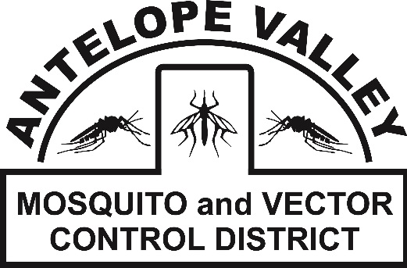 **Antelope Valley Mosquito**

**& Vector Control District**

42624 6th St. East

Lancaster, CA 93535

(661) 942-2917

**www.avmosquito.org**

**PRESS RELEASE**

For Immediate Release

**August 29th, 2025** **Contact:**

Brenna Bates-Grubb-Community Outreach Specialist

Zachary Russell- Mosquito Surveillance Technician

**First mosquitoes of 2025 test positive for West Nile virus in Palmdale, CA**

*West Nile virus is endemic in the Antelope Valley and the Antelope Valley Mosquito and Vector Control District continues to urge residents to take precautions against mosquito bites!*

**Lancaster, CA, August 29th, 2025**: Mosquitoes collected from a mosquito trap in Palmdale tested positive for West Nile virus (WNV). The trap was placed near 13th Street East and Avenue R. “These West Nile virus positive mosquito samples are a good reminder that WNV is active in the Antelope Valley and that residents need to be vigilant about personal mosquito control measures,” said District Manager Leann Verdick.

Hot weather is ideal to breed mosquitoes quickly. Stagnant water turns green more quickly and mosquitoes can go from egg to adult in just 5 days. Mosquito control is a shared responsibility of the property owner and the District. If both parties do their part to get rid of or treat standing water, the entire community will benefit from less mosquitoes and less chances of mosquito-borne diseases, such as West Nile virus.

AVMVCD personnel will continue to conduct intensive searches of the area surrounding this WNV detection as well as throughout the entire District to keep mosquito populations low and reduce the chances of residents getting ill. This includes following up with residents who have been identified as having unmaintained swimming pools. Please report any unmaintained swimming pools to the District as this remains one of the main breeding sources of West Nile virus mosquitoes.

People bitten by an infected mosquito may develop West Nile fever and experience flu-like symptoms that can include fever, body aches, skin rash, and fatigue. In some people, West Nile fever can develop into a more serious form of the disease and can even be fatal.

The District urges residents to do their part to protect themselves from mosquito bites by following these recommendations:

• Check property for standing water and get rid of it

• When mosquitoes are active, use EPA registered insect repellents that contain one of these main ingredients: DEET, Picaridin, Oil of Lemon Eucalyptus, IR3535 according to label instructions

•If weather permits, wear clothes that cover as much skin as possible; this reduces the areas of skin in which mosquitoes can access you for a bite

• Make sure your screens on windows and doors are in good repair to avoid mosquitoes inside the home

• Check around faucets and air conditioner units, and repair leaks or puddles that remain for several days

• Report daytime biting mosquitoes to the AVMVCD at 661-942-2917

• Report stagnant/dirty pools to the AVMVCD at 661-942-2917

• Report dead birds by calling 1-877-WNV-BIRD (877-968-2473) or online at [www.westnile.ca.gov](http://www.westnile.ca.gov) This helps the state track potential WNV hotspots

To stay up-to-date on new West Nile Virus activity in the Antelope Valley and any mosquito related information visit our website at [www.avmosquito.org](http://www.avmosquito.org), Facebook page (<https://www.facebook.com/avmosquito>), and follow us on X and Instagram @AVMosquito.

For any further questions or services please feel free to contact the Antelope Valley Mosquito & Vector Control District by phone (661-942-2917).