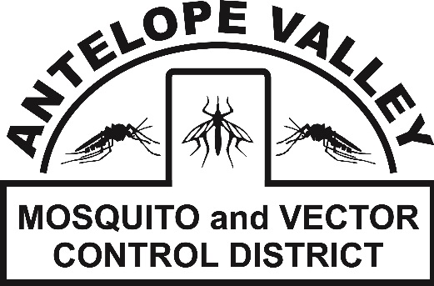
Antelope Valley Mosquito
& Vector Control District
42624 6th St. East
Lancaster, CA 93535
(661) 942-2917
www.avmosquito.org

PRESS RELEASE

For Immediate Release

September 1st, 2026 Contact:
Brenna Bates-Grubb-Community Outreach Specialist
Zachary Russell- Mosquito Surveillance Technician

Community Urged to Take Action as West Nile Virus Activity Increases

West Nile virus is endemic in the Antelope Valley and the Antelope Valley Mosquito and Vector Control District continues to urge residents to take precautions against mosquito bites!
Lancaster, CA, September 1st, 2026: With increased West Nile virus (WNV) activity in the community, the Antelope Valley Mosquito and Vector Control District is urging residents to take steps now to reduce mosquito breeding around their homes and protect themselves and their families from mosquito bites.

West Nile virus is transmitted to people primarily through the bite of an infected mosquito. The mosquitoes that commonly spread WNV, including Culex mosquitoes, can breed in standing water. Unmaintained swimming pools can become especially productive mosquito breeding sites.

“A neglected swimming pool can produce large numbers of mosquitoes right in the middle of a neighborhood,” said Zachary Russell, Mosquito Surveillance Technician. “With West Nile virus circulating in our community, maintaining your pool—or keeping it completely dry if it is not in use—is an important step residents can take to help protect their neighbors as well as themselves.” California public-health guidance specifically identifies unmaintained swimming pools as potential mosquito breeding sources and encourages residents to contact their local mosquito and vector control agency when they encounter neglected pools. Stagnant water, organic matter buildup, loss of chlorine, large water volume and warm, sheltered conditions provide the ideal habitat for mosquitoes to thrive, complete their lifecycle and create multiple generations of mosquitoes.

Keep Pools Maintained—or Completely Dry
Residents with swimming pools are encouraged to:
- Keep pools clean, circulating and properly chlorinated throughout the season.
- If a pool is not being used, do not allow it to become stagnant or green. Keep it properly maintained or completely drained and dry when appropriate.
- Check pool equipment, covers and surrounding areas for water that may collect and become stagnant.
- Report neglected or unmaintained swimming pools to the Antelope Valley Mosquito and Vector Control District at 661.942.2917 or https://www.avmosquito.org/submit-a-tip so vector-control personnel can investigate and help solve the problem.
The uptick in WNV detections this mosquito season is part of a statewide trend as mosquito districts throughout California report similar surveillance findings. “Other areas of Los Angeles County and mosquito Districts throughout California have also noticed an uptick in West Nile virus positive mosquito samples compared to the 2025 mosquito season.” said Surveillance technician Zachary Russell.
Hot weather allows mosquitoes to breed quickly. Stagnant water turns green more quickly and mosquitoes can go from egg to adult in just 5 days. Mosquito control is a shared responsibility of the property owner and the District. If both parties do their part to get rid of or treat standing water, the entire community will benefit from less mosquitoes and less chances of mosquito-borne diseases, such as WNV. “These West Nile virus positive mosquito samples are a solid reminder that West Nile virus is indeed active in the Antelope Valley and that residents need to remain vigilant about personal mosquito control measures around the home,” states District manager Leann Verdick. Even small amounts of standing water can provide breeding habitat, so eliminating these sources is an important part of community mosquito control.

AVMVCD personnel will continue to conduct intensive searches of the area surrounding these WNV detections as well as throughout the entire District to keep mosquito populations lowered and reduce the chances of residents getting ill. This includes following up with residents who have been identified as having unmaintained swimming pools.

People bitten by an infected mosquito may develop West Nile fever and experience flu-like symptoms that can include fever, body aches, skin rash, and fatigue. In some people, West Nile fever can develop into a more serious neuroinvasive form of the disease, with symptoms such as altered mental status, seizures, paralysis, and can even be fatal.

The District urges residents to do their part to protect themselves from mosquito bites by following these recommendations:

• Check property for any amount of standing water and get rid of it
• When mosquitoes are active, use EPA registered insect repellents that contain one of these main ingredients: DEET, Picaridin, Oil of Lemon Eucalyptus, IR3535 according to label instructions
•If weather permits, wear clothes that cover as much skin as possible; this reduces the areas of skin in which mosquitoes can access you for a bite
• Make sure your screens on windows and doors are in good repair to avoid mosquitoes entering into the home
• Check around faucets, yard drains and air conditioner units. Repair leaks or puddles that remain for several days
• Report daytime biting mosquitoes to the AVMVCD at 661-942-2917
• Report stagnant/dirty pools to the AVMVCD at 661-942-2917
• Report dead birds by calling 1-877-WNV-BIRD (877-968-2473) or online at www.westnile.ca.gov . This helps the state track potential WNV hotspots

To stay up-to-date on new West Nile Virus activity in the Antelope Valley and any mosquito related information visit our website at https://www.avmosquito.org/west-nile-virus-updates ,

For any further questions or services please feel free to contact the Antelope Valley Mosquito & Vector Control District by phone (661-942-2917).

